

**HIGH SCHOOL LAB INVENTORY MANAGEMENT SYSTEM**

**A SYSTEM REPORT**

**SUBMITTED BY**

**EUGENE KIMANI**

**DIT-02-0130/2022**

**TO MY SUPERVISOR**

**MR. NICHOLAS KAVOI**

**A SYSTEM REPORT DOCUMENTATION WRITTEN IN PARTIAL FULFILMENT FOR THE AWARD IN A DIPLOMA IN INFORMATION TECHNOLOGY BY ZETECH UNIVERSITY**

**DECEMBER, 2022**

**DECLARATION----------------------------------------------------------------------------------------------------------------**i

**ACKNOWLEDGEMENT----------------------------------------------------------------------------------------------------**ii

**DEFINITION OF KEY TERMS-------------------------------------------------------------------------------------------**iii

**ABBREVIATIONS AND ACRONYMS----------------------------------------------------------------------------------**iv

**LIST OF FIGURES---------------------------------------------------------------------------------------------------------------------**v

**ABSTRACT-------------------------------------------------------------------------------------------------------------------------------**vi

**LIST OF TABLES------------------------------------------------------------------------------------------------------------**vii

**CHAPTER ONE: RESEARCH INTRODUCTION--------------------------------------------------------------------**1

* 1. **Research problem------------------------------------------------------------------------------------------------------**2

**1.2Research objectives-----------------------------------------------------------------------------------------------------**3

**1.2.1 General objective ----------------------------------------------------------------------------------------------------**5

**1.6 Problem scope------------------------------------------------------------------------------------------------------------**6

**CHAPTER TWO: LITERATURE REVIEW** 6

2.1 Introduction 6

use of the application. 6

2.2 Global Review/2.3 Regional Review/2.4 Local Review 6

2.3 Empirical Review 7

**CHAPTER THREE: SYSTEM METHODOLOGY AND DATA COLLECTION** 8

3.1 Introduction 8

3.2 System Requirements Specification 8

3.2.2 Non Functional Requirements 9

CHAPTER FOUR: DETAILED DESIGN OF THE SYSTEM 10

3.3. Design 10

3.3.1 Low Level Design 10

CHAPTER FIVE: IMPLEMENTATION OF SYSTEM DESIGN AND TESTING 12

5.1 Implementation 12

5.2. System Requirements 12

3.5 Testing 13

CHAPTER SIX: SYSTEM DOCUMENTATION 15

6.1.2 Login Using Usernames and Passwords 15

**CHAPTER FOUR: CONCLUSION AND RECOMMENDATIONS** 21

4.1 CONCLUSION 21

4.2 RECOMMENDATIONS 21

**CHAPTER FIVE: REFERENCES AND APPENDICES** i22

5.1 REFERENCES i22

5.2 APPENDIX I: i23

# 

# **DECLARATION**

I declare that this is my original work and the same has been submitted for the award and qualification in my Diploma in Information Technology final project in Zetech University.

**STUDENT DECLARATION**

**NAME:** EUGENE KIMANI DIT-02-0130/2022

**DATE: ……………………………………..**

**SIGN: ………………………………………**

**SUPERVISOR DECLARATION**

NAME: MR.NICHOLAS KAVOI

**DATE: ……………………………..**

**SIGN: ………………………………**

# **ACKNOWLEDGEMENT**

I learned a lot from this project, High School Lab Inventory Management System, and I'm submitting it to the ICT department at Zetech University. EUGENE KIMANI DIT-02-0130/2022 I would want to use this opportunity to first and foremost thank and convey my sincere gratitude to my guide, Mr. Nicholas Kavoi (Lecture, Department of ICT, and Zetech University). He gave me invaluable advice at every step of the study, helpful recommendations, a positive and encouraging attitude, and ongoing encouragement, all of which made it possible for me to finish the project. I am very grateful to him.

# **DEFINITION OF KEY TERMS**

**Database -** Is an organized collection of structured information, or data, typically stored electronically in a computer system.

**Complaint-** A statement that something is unsatisfactory or unacceptable

**Grievances-** A complaint or a strong feeling that you have been treated unfairly

**Concerns-** To relate to or to affect, to interest or engage, or to worry

# **ABBREVIATIONS AND ACRONYMS**

HTML - Hypertext Mark-up Language

PHP -Hypertext Pre-processor

MYSQL - Structured Query Language

VB.NET - Visual Basic

IDE - Integrated development environment

**ABSTRACT**

The purpose of this project is to develop a local host system that students, instructors, and administrators can use to aid in the facilitation of laboratory administration. Although it will be designed with students in mind, the staff and administration will also play a very important role in supervising and advising the students on how to make the greatest use of this system. It will have practical components that will be utilized to take the role of the manual method, which heavily relies on keeping track of and maintaining laboratory inventory with the aid of books and other records. This system recognizes the value of using technology due to its effectiveness and efficiency. The existing educational system relies heavily on handwritten inventory, which is frequently inaccurate and damaged.

The objective of this study project is to develop an effective, dependable, and secure inventory system that will keep track of objects that have been taken or damaged in order to promote their use and movement by maximizing the benefits of incorporating technology. This system will aid in resolving issues like lost borrowed items, tracking damaged and returned items, and reservation timelines. This will be handled in a prompt manner with clear communication. Utilizing the APA 7 referencing format, this essay has been reviewed and referenced. Primary data was gathered through interviews. To create extensive analyses using graphs and charts, MS Excel was employed.

# **LIST OF FIGURES**

3.3.1 Low Level Design

3.3.2 High Level Design

# **LIST OF TABLES**

# 5.4 APPENDIX III: GANTT CHART

**CHAPTER ONE: RESEARCH INTRODUCTION**

* 1. **Research problem**

The research proposal provides analysis in depth on the structures that will be needed to build an efficient High School Lab Inventory Management System. It is designed for management and utilization of laboratory items so as to ensure efficiency and easy access of lab items by the students and administrators.

Among the major concerns that this system addresses include easier access to lab items, proper utilization of items, keeping track and checking on their quality so that students might develop keen interest in proper management of Lab equipment. This also enables the student to make time in their schedules and carry out practices that will help boost their understanding of concepts learned in class through a practical experience. Other concerns might be where students might require extra learning time and this will be aided by creating a system that make reservation so that the students can plan themselves well on when to carry out the practical.

A major problems that is also being faced by students is their mistrust in the Suggestion Boxes placed around the campus that always seem dusty and never unopened and this gives lecturers trust issues as they believe that they are not being opened or even misused as other people will throw litter in these suggestion boxes and thus they may not be comfortable to write down or even speak out their issues.

The current method of issuing complaints here at Zetech include dropping off concerns to the lecturers supervisor, dropping off a letter in the suggestion box or writing to the e-mail feedback@zetech,ac,ke which will sometimes not give feedback in any fashion. With the many number of e-mails coming in at a go sometimes the important grievances might be mixed in the clutter of big number of unrelated mails come in and thus the complaints grievances and concerns will go unaware and when they are required for review locating the right one might be time consuming.

**1.2Research objectives**

**1.2.1 General objective**

Developed an online based student’s welfare system for grievances, complaints and concerns.

.

**1.2.1 Specific objective**

Developed modern interactive software that will help universities in handling of complaints, grievances and concerns.

Designed a system that will be used in detecting problems that pose obstacle with a view of modifying the operations and developing a new computerized system that will be more efficient and accurate such as in the area of complaints of vital concerns a computer will be used to record store and retrieval of large volume of complaints.

To enable easy retrieval and access to grievances, complaints and concerns information.

To reduce the grievances submitted by students due to inconsistency in activities and time that is taken in search of file when it is required for processing

**1.3Background information**

A web based system is a way of eliminating the need for human interaction and mistakes. This will allow for the system to interact well with the end user in receiving or retrieving information from sender to receiver in order to sort the issue presented, the system will be of high integrity and thus privacy on serious issues that require anonymity will be included served as sent by the user at a much more efficient timeline. The system will allow the administration and organization at large to monitor past on going and upcoming issues that need to be worked on or constantly worked on all while saving time and for students to be able to air out issues and find resolve in order to keep a peaceful and conducive environment for everyone. A system should be followed when airing out an issue in mind where you present it, the issue is discussed by the right offices ensuring the right protocols are followed. There should be a timeline in order to see whether issue has been resolved, if within the timeline the work has not been done the student can enquire or the management may ask for more time to work on presented issue. There has to be a system where we can see that issues have been resolved amicably and to the best of the management’s abilities.

**1.5Limitation of the study**

I anticipated experiencing challenges in using observation as a data collection tool since there were no local colleges or universities around using the system that I can learn from. I anticipated experiencing a challenge in collecting live samples of lecturers of universities using the system therefore I worked only with non-living samples from my internet.

**1.6 Problem scope**

This study is specifically concerned with the computerized of university complaint, grievances and concerns model.  Although many activities are being performed in universities, this work is therefore concerned in university complaint, grievances and concerns model..

.

# **CHAPTER TWO: LITERATURE REVIEW**

## 2.1 I**ntroduction**

In this section of the research paper, I seek to study and determine similar systems that are already in existence and have been implemented, in order to see how they work, and provide deeper insight in this area of interest that made me found out strengths and weaknesses and the role they have played in their different use of the application.

## 2.2 Global Review/2.3 Regional Review/2.4 Local Review

The system is to be used to improve the current school system in delivering effective services while listening and taking in complaints and concerns that takes a long process that leaves a student unsure of services rendered while giving out their grievances, complaints and concerns. The system is also able to identify systemic and repetitive administrative problems.

Currently the system in use in Kenyan colleges and even Zetech the procedure is to send your grievances and complaints to an e-mail while most concerns are sent via the suggestion box, other institutions will ask the student to download a PDF file that is then edited or printed then sent back to the site in order for grievances to be sorted.

Online systems in other countries I looked into The University of Queensland which is a top research and learning institution, has a complaints management system that assists in fluidity of school services. Their system allows for a variety of complaints related to discrimination, misconduct, harassment, discrimination and personal privacy breach issues can also be handled using the online system. The system extensively covers issues and has a lodge a complaint tab.

Through the research we have done from both Zetech University and The University of Queensalnd we have been able to deduce that Web based complaint management systems provides an online way of solving user based problems(student) while saving time. Main objective of the complaint management system would be to make complaints easier to track, coordinate, monitor and resolve. In the work of Cathy Constantino, Christina S. Merchant, Karl A Slakeu and Ralph H Harrison their presented work on Online Complaints system gives an insight on the design of the proposed Complaints Management System by keeping in mind current current and future requirements of the system and provides an efficient tool that helps to identify and target problem areas, monitoring complaints handling performance and make improvements as time goes by.

Yooncheong Cho, Il Im, Roxanne Hiltz & Jerry Fjermestad in 2002 stated that web based customer complaint systems. Work presented showed that current online complaint systems handle critical issues that stem from customer satisfaction which is one of the main problems of online customer service solutions. Effective ways of handling complaints were examined and after thorough research, a tool was built based on the guidelines that were used in developing a successful complaint management system. Research from authors shows that a successful system must be built on a stable strategy with consistent flow that focuses on retaining the customer.

## 2.3 Empirical Review

Many authors extended the work of Berenbeim, Rowe, and Rowe and Baker, on the topic of internal complaint systems. They included: Douglas M. McCabe, William J. Ury, Jeanne M. Brett, and Stephen B. Goldberg. Cathy Costantino and Cristina S Merchant, and Karl A. Slaikeu and Ralph H. Hasson extensively explored issues of designing conflict management systems.

The concept of an integrated conflict management system was conceived and developed by Mary Rowe, in numerous articles in the 1980s and 1990s. She saw the need to offer options for complainants and therefore a linked system of choices within an organizational system. The idea of a systems approach has endured well. In recent years however, there has been discussion as to whether conflict should be "managed" by the organization—or whether the goal is to understand, deal with and learn from conflict. There is also concern about practical and theoretical issues in "integrating" a system, with some observers preferring the idea of "coordinating" a conflict system. However 2012 research by David Lipsky et al., suggests that an increasing number of corporations see themselves as having "integrated conflict management systems," or "ICMS."

# **CHAPTER THREE: SYSTEM METHODOLOGY AND DATA COLLECTION**

## 3.1 Introduction

This chapter will in detail explain the system methodology that i used and how it’s going to play a role in my developed system. From my research and literature review, after having investigated existing complaint system and understanding how they work and how most of them have been designed, I anticipated to use the agile modelof system development lifecycle as it help me understand how the system must be designed from top, down, and enabled me focus on the specific objectives.

**3.1.1 Agile Model**

I anticipated using the agile model and following the five main steps, which are:

1. System Requirements Specification
2. Design
3. Implementation/Development
4. Testing
5. Deployment
6. Maintenance

## 3.2 System Requirements Specification

### 3.2.1 Functional Requirements

### Functional requirements describe what the Web-based online university complaint, grievances and concerns system should do or the behaviors of the system and below are the requirements it satisfied;

### The system provides a login interface through which only authorized users are allowed to use based on their roles (Administrators, students).

### The system allows administrators to manage, that is add and delete students

### The system supports online to allow access from anywhere

### The system supports any device that can access a webpage online

### The system handles multiple users simultaneously

### The system allow administrators to monitor activities of logon students

### The system supports all web browsers with cookies and JavaScript enabled.

### The system uses MySQL as the DBMS for database.

9. The system uses PHP as the server side script and run using Apache web server software

### 

### 3.2.2 Non Functional Requirements

A non-functional requirement places constraints on how the web-based university complaint, grievances and concerns system should work or elaboration of the performance characteristics of the system. Below are the requirements it satisfied;

1. The system have an interface that is user friendly, easy to follow and indicate the name and unit of the authorized user.
2. The system have an interface that produces relevant error messages related to user login and system usage
3. Access to features such as data and backup of database should depend on users designated role The web server software should offer good performance by employing server-side caching
4. The system should be available 24 hours, 7 days a week and can be accessed anytime
5. The system should have a server side backup of 12 hours duration and UPS support for 24 hours, 7 days a week to limit server down times
6. The system should not cost more than Ksh70,000 and web hosting for a year should not cost more than Ksh10,000.
7. The system is implement SSL (https) and RSA encryption to secure the contents of the system
8. The system should use MySQL version 5.6 and above as the DBMS for database.
9. The system should contain a minimum number of students details by using MD5 to encrypt records stored in the MySQL DBMS
10. The system uses HTML, CSS, JSP, PHP, etc. which are platform independent and can be implemented with minimal efforts
11. The system uses PHP version 5.5 as the server side script and run using Apache version 2 as web server software
12. 12.The system runs on windows with at least 2GB RAM and 500 GB hard disk space

## CHAPTER FOUR: DETAILED DESIGN OF THE SYSTEM

**4.1 Design**

The functional processes of this system are the major features that the system has or performs. A functional model or functional process in system development is a structured representation of the functions, behaviours, activities or processes of the system or subject area. The functional process of the system include all the working and operational processes of the entire system.

## 3.3. Design

### 3.3.1 Low Level Design

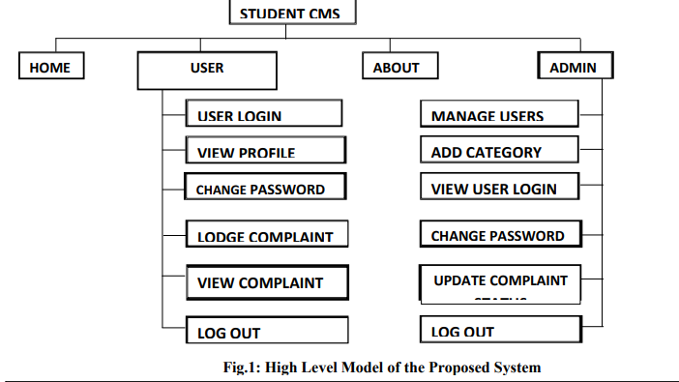

**3.3.2 High Level Design**

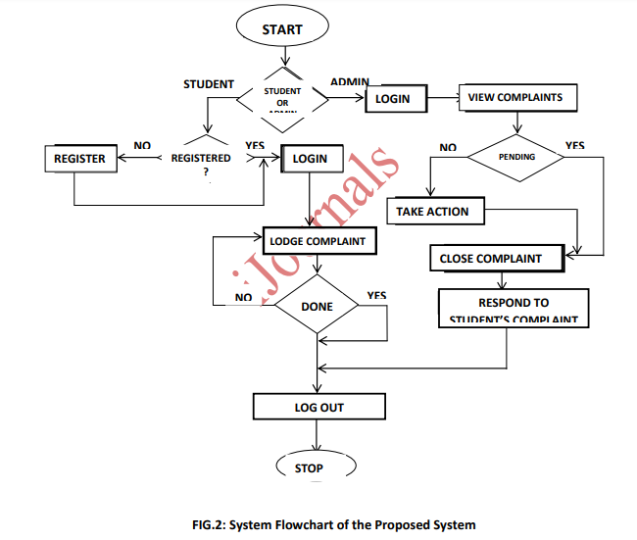

## CHAPTER FIVE: IMPLEMENTATION OF SYSTEM DESIGN AND TESTING

### 5.1 Implementation

The implementation of the system presents the development, installation, testing and deployment of the system proposed. The implementation of the system integrates all other development steps to build a functioning system after detailed study and design of the system.

### 5.2. System Requirements

The hardware needed for the patient diagnosis to operate are as follows; The Processor should be Pentium 4 and above, a minimum of 4 Gigabyte of RAM and a hard disk space of 50 Gigabyte and above.

The software requirements are listed below;

1. Windows, Operating Systems

2. SSL certificate (https) and AES encryption to secure the contents of the system (online mode)

3. MySQL version 5.6 as the DBMS for database.

4. PHP version 5.5 as the server side script

5. Apache version 2 as web server software

6. Mozilla, Google Chrome, Internet Explorer, Safari web browsers

**5.3. How to Install**

1. The method of installing the application requires the web application to be hosted live on either a public or a private web server.
2. For a local web server, the XAMPP application version 3.2.2 and above which comprise of all the required software can be installed by adhering to its manual
3. All the files contained in the application must be extracted and placed in the htdoc/www folder and the appropriate permissions set for it.
4. The database along with the required tables must be created whiles ensuring a connection of the application to the database.
5. The administrator visits the URL for the application to ensure the setup was successful.
6. The web application will be ready for use when it has been hosted and installed without challenges.

## 3.5 Testing

The following are the perquisite quality aspects adhered to in the processing of testing the Web-based university complaint, grievances and concerns System. The contents were evaluated at both syntactic and semantic level.

Syntactic standard tests for text-based records covered spelling, grammar and punctuation. The evaluation of semantic evaluated information provided, consistency among the whole object of the content and linked objects and absence of information uncertainty.

The functionality of the system was tested for consistency, instability and general conformity with acceptable levels of execution. The structure has been reviewed to ensure that the content and operation of the Web Application is adequately delivered and expandable and can be supported if additional content or functionality is introduced. Usability test aims to verify that the user interface is friendly and will permit easy navigation as well as understanding instructions provided.

To guarantee that both syntax and semantics required to navigate are applied to detect possible navigational errors, navigability has been tested. Dead links, improper connections or erroneous connections are detected and amended in a range of operating conditions, configurations, and processing performance was checked to ensure that the system is sensitive to user input and thus manages extensive loading without excessive operational deterioration.

Compatibility has been tested by running the Web application both on client and server side in a number of different host environments (Windows).

The motive is to detect errors associated with a given configuration of the host.

Interoperability has been checked to determine that the Web Application interacts appropriately with other software and backend databases.

Security was evaluated by determining and striving to exploit possible vulnerabilities. Any successful penetration attempt is known to be a security breach.

**5.5. Implementation Method**

This involves the manner in which the system is implemented. It consists of activities relating to the development and programming of the system, system review, and migration from the legacy regime to the current system. Change over procedure is the transition from the legacy or previous practices to the new web-based complaint system application the direct changeover method is primarily used where design and implementation of the new framework is highly trusted. This is primarily used when there is a deep faith in the new system's creation and delivery. It requires a complete overhaul of the old system when the new system is introduced. The Pilot changeover method includes pre-testing the newly acquired system using the same type of data in a different or isolated testing environment. This technique offers a chance to assess the operating stability of the systems and the possibility of changing all at once. In a phased changeover method, before the end of the complete conversion, changeover is carried out gradually. This is used when traditional and new systems are identical in appearance. However, the changeover or conversion approach was the parallel method. This is to accommodate for some time the running of both the new and old system concurrently to ensure that the new system satisfies the specifications to which it is implemented.

**5.6. Review and Maintenance of the System**

The new system must be regularly tested to present unintended problems that may occur in the function of the system's use and to give space for system upgrade if necessary. File maintenance operations includes the deletion, insertion as well as rearrangement and modification or amendment of records. File maintenance works are easily performed due to the various advantages provided to this new system by its index sequential file access process.

### CHAPTER SIX: SYSTEM DOCUMENTATION

**6.1. Documentation**

For the new system to be successful there is the need for documentations or manuals aimed at the following

1. Educating students on the current system's objectives and advantages.

2. Educating students of the current system on management roles or tasks and obligations.

3. Educating students on the procedure for undertaking tasks and functionalities on the new system

4. Most importantly, making the system documentations available to users.

**6.1.1. Launching the Complaint System**

Please follow the sequence of steps to launch the application;

1. Double click on a web browser icon

2. Locate the address bar and type localhost/complaint1

3. Press on go button or press enter on the keyboard

### 6.1.2 Login Using Usernames and Passwords

### Please follow the sequence of steps to enter access credentials for validation.

### 1. Click on login hyperlink

### 2. Locate and enter usernames and passwords in their appropriate fields

### 3. Click on Login button or press enter on the keyboard

4. Wait for the credentials to be validated to access the interface

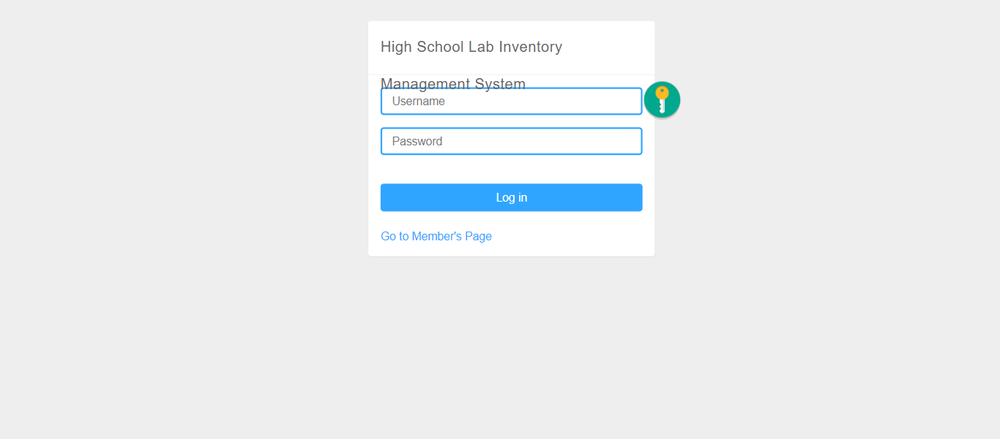

**6.1.3 Inventory panel**

Please follow the sequence of steps to enter access credentials for validation;

1. Click on ‘inventory’ hyperlink
2. The inventory section for this system has columns that record specific information about the items. This section also enables the administrator to control full access of the inventory and monitor the items. This also enables the admin to check the status of the items if they are damaged or lost. This will allow the administrator to follow up the status of the item. 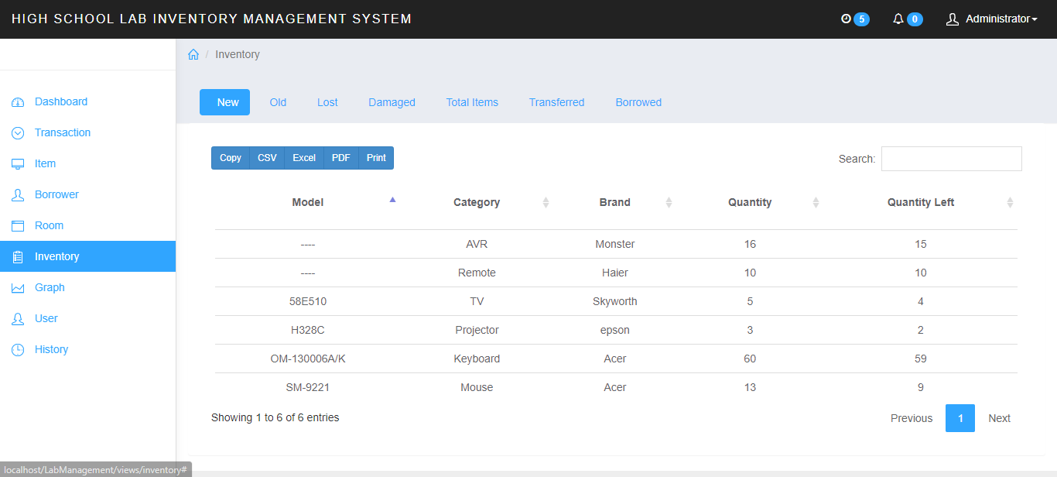

**6.1.3 Item panel**

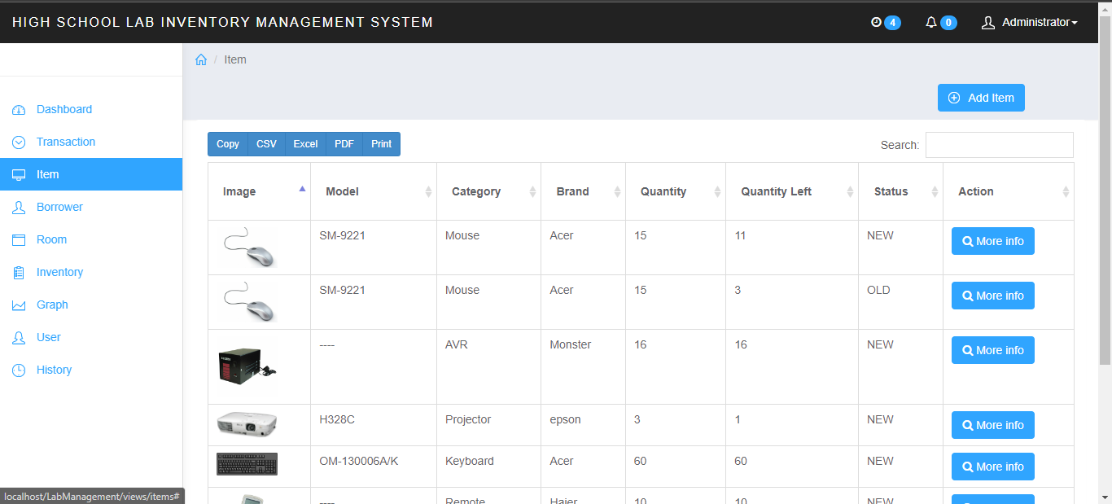

**6.1.4 transaction panel**

Please follow the sequence of steps to view the completed timetable

The Transaction panel contain keys areas that helps to monitor movement of items . The Reservation section is an area where a user to book and add an item. This section captures user information such as name, item reserved, room allocated, date and action. The “New Section” allows the user to borrow items to a maximum of five. It also indicates room allocation and time limit of the borrower. The Borrowed Items section contain the borrower’s details such as name, Items borrowed, Date borrowed, room allocation and action taken. The Return section collates user information based on the items they have borrowed and returned.

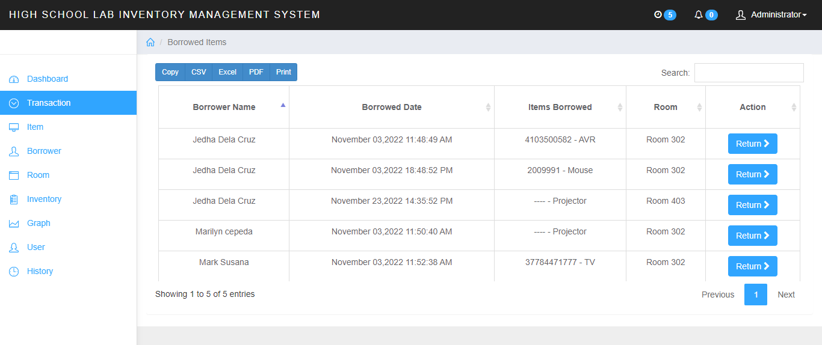

**6.1.4 Graph panel**

The graph section contains graphical representation of each item used, borrowed or returned to the Lab. This allows the admin to keep track of items and understand user preference.

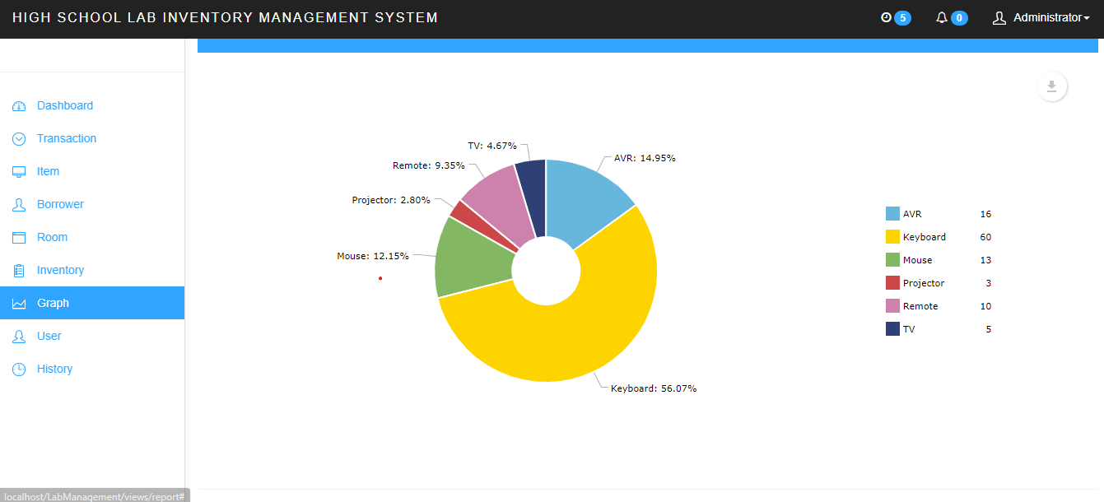

**6.1.4 USER PANEL**

Other sections in the user panel include the Action area and a command section that enables the user to view the document in other forms. This section can also enable the administrator to collect and collate user information in an Excel format. The Action area enables the administrator to edit, deactivate or change passwords. This allows the administrator to have full access to the system and monitor user movement.

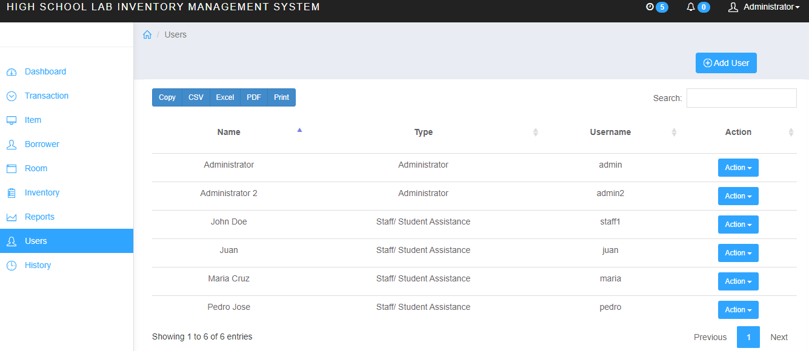

**THE ADMIN DASHBOARD**

This section contains log in information that allows the user to access the system. Some of the keys features include Username section, password section and a link “Go to Member’s Page” which directs the user to regain access to the system incase they loose the encryption key.



# **CHAPTER FOUR: CONCLUSION AND RECOMMENDATIONS**

## 4.1 CONCLUSION

Application software has been computed successfully and was also tested successfully by taking “test cases”. It is user friendly, and has required option, which can be utilized by the user to perform the desired operations. Application software meets the information requirements specified to a great extent. The system has been designed keeping in view the present and future requirements in mind and made very flexible.

The goals that are achieved by the software are Instant access, improved productivity, Optimum utilization of resources, Efficient management of records, Simplifications of the operations, Less processing time and getting required information, User friendly, Portable and flexible for further enhancement.

## 4.2 RECOMMENDATIONS

I recommend before the application is put into full use, it should be tested in sample field to eliminate any bugs that may not have been identified at the time of development password levels may be increased to higher levels depending on the confidentiality of the stored data. The current system password is basically low level. The researchers need to do more on their research to improve on the future of college welfare complaint and grievances to enable the college move with the current trend and maintain its sustainability. The use of modern technology and equipment’s in the colleges should be on the high end of use to output top notch services and best working and student’s effect during work time. The use of latest apps in colleges would also be good to enhance the productivity of colleges which will be able to boost the business.

# **CHAPTER FIVE: REFERENCES AND APPENDICES**

## 5.1 REFERENCES

Bouchrika, I. (2022, June 20). *Best Lab Inventory Management Software*. Research.com. <https://research.com/software/best-lab-inventory-management-software>

Gawkowski, P. (2022). *Laboratory Information Management Software*. www.solution4labs.com. <https://solution4labs.com/en/laboratory-information-management-software-lims-101>

Sartipi, K., & Edoh, T. (2021). *Recent advances in digital system diagnosis and management of healthcare*. BoD – Books on Demand.

- School lab safety management. (2016). *The Comprehensive Handbook of School Safety*, 262-271. <https://doi.org/10.1201/b12700-25>

## 5.2 APPENDIX I:

**INTERVIEW**

1. What is current system used in the organization?

2. Are there any challenges with the existing system?

3. If any, what are the problems faced?

4. Give any suggestions on how the problems faced with the existing system can be solved.

5. What are the services offered in the supermarket?

6. How the records are stored if any and are they secure enough?

7. How many departments does the supermarket have?

8. If the system is to be improved, what changes would you suggest to be made?

**5.4 APPENDIX III: GANTT CHART**

|  |  |  |  |  |  |  |  |  |  |  |  |  |  |  |
| --- | --- | --- | --- | --- | --- | --- | --- | --- | --- | --- | --- | --- | --- | --- |
| **WEEKS** | | | | | | | | | | | | | | |
| **ACTIVITIES** | **1** | **2** | **3** | **4** | **5** | **6** | **7** | **8** | **9** | **10** | **11** | **12** | **13** | **14** |
| Interface prototypes |  |  |  |  |  |  |  |  |  |  |  |  |  |  |
| Main homepage |  |  |  |  |  |  |  |  |  |  |  |  |  |  |
| Catalogue Module |  |  |  |  |  |  |  |  |  |  |  |  |  |  |
| Office management Module |  |  |  |  |  |  |  |  |  |  |  |  |  |  |
| Database |  |  |  |  |  |  |  |  |  |  |  |  |  |  |
| System integration |  |  |  |  |  |  |  |  |  |  |  |  |  |  |
| System design |  |  |  |  |  |  |  |  |  |  |  |  |  |  |
| Testing and Deployment |  |  |  |  |  |  |  |  |  |  |  |  |  |  |
| Panel Presentation |  |  |  |  |  |  |  |  |  |  |  |  |  |  |
| Final modifications |  |  |  |  |  |  |  |  |  |  |  |  |  |  |

## 